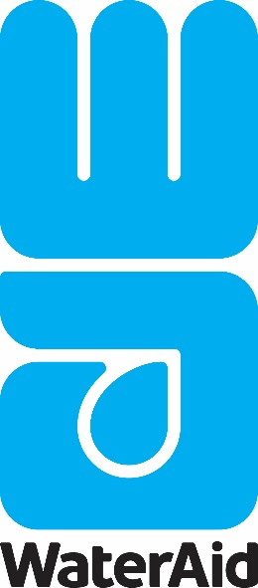
Job Description
Project Officer (Uganda)
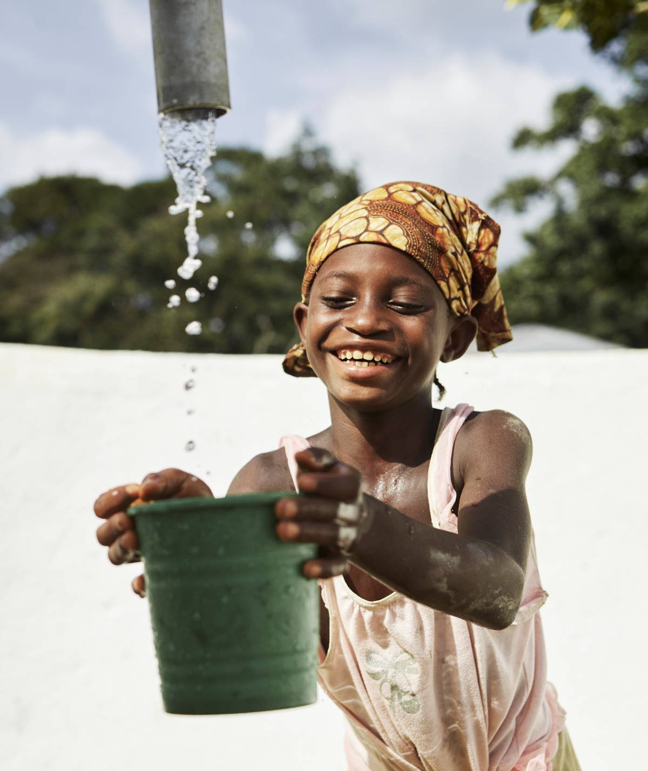
Project Officer
Place of work: | Kampala, Uganda
Pay band: | Current Grade D
No. of Positions | Two (2)
Reports to: | Policy Advocacy and Campaigns Manager
Contract type: | One Year
Background:
WaterAid Uganda (WAU) is an International NGO specializing in water, sanitation and hygiene and it envisions a world where everyone, everywhere has access to safe water, sanitation, and good hygiene. With funding from the Conrad N Hilton Foundation, WAU is set to implement projects aimed at Strengthening policy systems to accelerate coverage of WASH in Health Care Facilities in Uganda. The projects will seek to inform policy and apply a system strengthening and empowerment approach throughout, underpinned by a rights-based approach, and by linking and leveraging work at local, regional, national, and global levels.

WaterAid recognizes the importance of safe water in HCFs. However, to improve water quality and systems, we need to recognize the interlinkages between water, sanitation, and hygiene within HCFs. Therefore, this project will focus primarily on water, but also address critical related issues of improved sanitation and hygiene which has a direct impact on water quality and systems. WAU will draw from both its global and national experience in WASH in HCFs work both as an advocate for access rights and a facilitator of policy discourse based on evidence and best practice.

WaterAid Uganda is now recruiting a suitably qualified candidate of impeccable integrity and commitment to fill the position of Project Officer who will be responsible for the planning, organizing, and leading on the project implementation, monitoring and reporting.

JOB PURPOSE SUMMARY:
The Project Officer will lead the planning and guiding the implementation of WASH in Health Care Facilities activities. They will ensure the development of activity concept notes, terms of reference and development works. They will participate in the development and maintenance of effective WASH in Health Care Facilities M&E systems, documentation and learning.

KEY RESPONSIBILITIES:

Project Panning, Implementation and Reporting

- Actively contribute to planning and guiding the implementation of WASH in Health Care Facilities activities and follow-up to ensure the CNHF project is on track to achieve intended objectives
- Develop activity concept notes, Terms of Reference for trainings and other consultancy works
- Organise key sub-national WASH events in collaboration with partner local governments
- Conduct regular monitoring of all projects sites; planned, ongoing and completed activities
- Prepare project documentation including monthly project reports on implementation status, intermediate and final narrative reports as per donor requirements
- Develop and conduct related trainings to health workers, health Unit Management Committees (HUMC), WASH committees and to other relevant stakeholders.
- Coordinate and participate in project reviews and project closure workshops, baseline survey and end of Project Evaluation for the project as per project design and within the project implementation deadlines
- Liaise with WAU Finance Department in tracking project expenditure, reviewing financial reports, and addressing queries related to expenditure in timely manner.
- Carry out specific administrative, operational/control tasks for project activities, arrange for the recording and administrative processing of payment requisitions and accountabilities for planned and implemented activities
- Build relationships and coordinate outreach among stakeholders participating in the project planning process.
- Liaison with Advocacy Manager in development of advocacy policy briefs and position papers, from key issues emerging from the project implementation.
- Participate in district level health stakeholder meetings – document meeting minutes, assists with planning and following up actions points.
- Work closely with Communications Officer in management of project information and documentation processes and ensure effective communication of the project results.
- Build, maintain and effectively manage strategic partnerships and collaborations with the various district and partner offices, including Ministry of Health, regional technical deconcentrated structures
- Support collaboration with other Implementing partners and other partners at field level
- Represent WAU at district and in-country engagements and other professional meetings as requested by the Line Manager.

Participate in the Development and Maintenance of an Effective WASH in HCF
M&E System, Documentation and Learning

- Participate in the continuous review of the M&E system with specific emphasis on providing support to the update and management of the WASH and HMIS reach database.
- Support updating project data as per the WaterAid Planning, Monitoring and Evaluation (PMER) procedures
- Provide on-going support supervision and monitoring to health facility structures to ensure delivery of quality WASH services
- Communicate learning for internal and external audiences on project implementation progress
- Develop and share success stories on WASH in HCFs occasioned by the project
- Track best practices in monitoring and evaluation of the CNHF project
- Organise joint partner reflection and planning meetings
- Coordinate partner monitoring visits and performance review meetings
- Ensuring that project implementation conforms to quality standards and best practices
- Risk Management - Monitor and address or report any risk to management.

JOB REQUIREMENTS/PERSON PROFILE:
- University degree in Development Studies, Social Sciences, Education, Social Work and Social Administration, Law, or any other related field.
- Minimum 3 years’ experience relevant in advocacy and to the duties described above.
- Experience in WASH in Health Care Facilities would be a strong advantage.
- Proven knowledge of and professional experience in project management.
- Planning and organizational skills.
- Strong communication skills both written and spoken English and confidence interacting with a range of different stakeholders
- Excellent organizational skills, proven ability to manage competing demands on time while still meeting deadlines.
- Very strong attention to detail, able to deliver work of a high standard
- Highly motivated, able to self-start and proactively seek guidance or direction where required
- Team player with commitment to collaborative working
- Excellent computer skills and ability to work independently and efficiently with the following office tools: Word, Excel, PowerPoint, Outlook.

Apply
If you are interested in the position and have the right skills and attributes, complete and fill the job application form HERE

WaterAid is committed to ensuring that wherever we work in the world there is no tolerance for the abuse of power, privilege or trust. WaterAid reinforces a culture of zero tolerance towards any form of inappropriate behaviour, abuse, harassment, or exploitation of any kind. The safeguarding of our beneficiaries, staff, volunteers and anyone working on our behalf, is our top priority, and we take our responsibilities extremely seriously. All staff and volunteers are required to share in this commitment through our Global Code of Conduct. We will conduct the most appropriate preemployment references and checks to ensure high standards are maintained.

WaterAid is an equal opportunities employer and positively encourages applications from suitably qualified and eligible candidates regardless of sex, race, disability, age, sexual orientation, gender reassignment, religion or belief, marital status, or pregnancy and maternity. We particularly encourage applications from women who are underrepresented at this level in the organisation.

